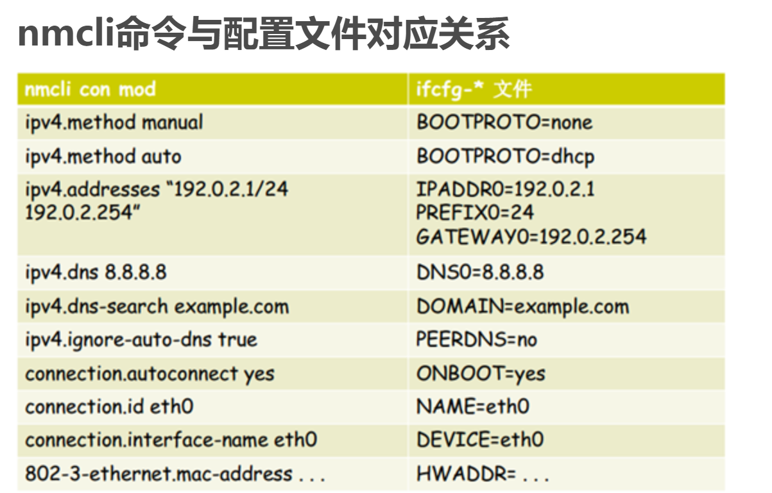
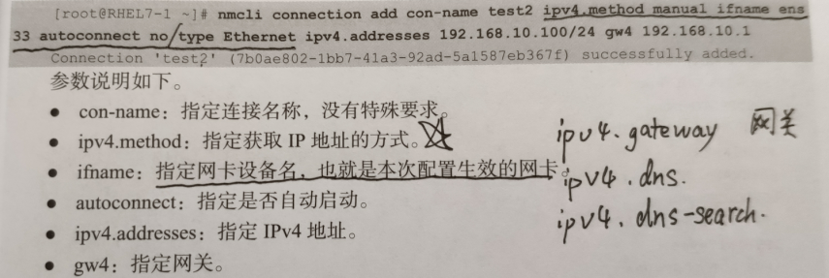

Dhcp访问外网
Nmcli con mod 网卡 ipv4.method manual connection.autoconnnet yes
Systemctl restart network
Nmcli con up 网卡

